
FOR IMMEDIATE RELEASE

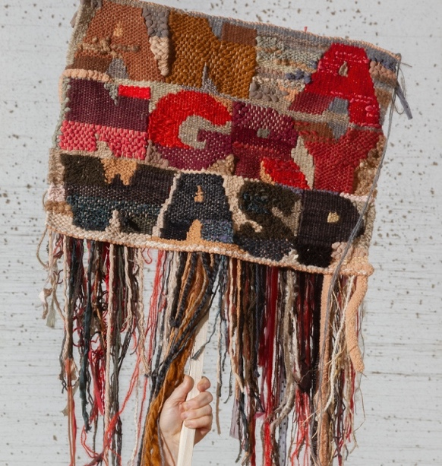
Jodi Colella: Dangerously Close to Home
February 26 - March 29, 2026

First Friday
March 6, 5- 8:30pm

Reception & Artist’s Talk
Saturday, March 14, 2- 5pm
Talk begins at 3pm

Gallery Hours
Wednesday – Sunday, 11am – 5pm

Boston, MA – Boston Sculptors Gallery presents Jodi Colella’s solo exhibition Dangerously Close to Home, on view February 26 - March 29, 2026. Engaging an overlapping discourse about craft, women’s work, power and feminism, Colella crafts domestic items made with humble materials, historic tools and quotidian labor into objects that distort traditional signals of comfort into a means of revealing discomfort.

Colella’s rag rugs, lace doilies, and decorative hand towels flaunt quirky sayings lifted from a century’s old word game. Recontextualizing period phrases to capture the language of 21st century culture, Colella reflects today’s coded patterns of speech and cleverly bypasses polite norms. In this age of censorship and retaliation, she uses humor and covert messaging as an act of dissent.

Words are pictures, works of art are meant to be read, and the objects in Dangerously Close to Home do the talking. Voices historically stifled by patriarchal hierarchies are amplified within the textile structures formerly denigrated as women’s work. Colella is one of a long line of women engaging in needlework to perform their gender role while pushing the boundaries to expand freedoms. Her compulsion to master multiple processes of craft propels her revival of these practices into subversive conceptual declarations and protest.

Jodi Colella exhibits and teaches internationally. She is the recipient of a 2019 Massachusetts Cultural Council Fellowship Award for Sculpture. Her exhibitions include The Textile Museum in Washington D.C.; Textile Center, Minneapolis; Fuller Craft Museum, Brockton; and Da Wang Culture Highland in Shenzhen China among others. She has collaborated on several public art projects, and her work is held in multiple museum and private collections.

Jodi Colella: Dangerously Close to Home runs concurrently with Chris Frost: Debris.
# # #
Contacts:
Almitra Stanley, Director
617.501.5600
bostonsculptors@gmail.com
www.bostonsculptors.com
Jodi Colella, Artist
781.724.8686
jodi@jodicolella.com
JodiColella.com

